Practical 2 – Scheduler
Overview
Our task was to implement a user space scheduler in C. The scheduler had to be able to read in process data from a conf file, and schedule them using the round robin scheduler design. An optional extension was to implement process priority handling, where processes of higher priority (priority closer to 0) would be executed before those of lower priority (priority approaching 20).
Design
My code is organised into three main files: the scheduler implementation in my_sched.c, line processing and linked list operations in pc_block.c, and constants, struct tyedef, and function headers in the sched.h header file. There are additional files that are used to test program execution.
When ran from the command line (ideally as $ ./sched <config_file_path>), the program does basic sanity checking to make sure a file path is provided and that the file can be opened (see Figure 1). If a file is read successfully, tit is read line-by-line using fgets() and, given correct details, is transferred into a proc struct.
The proc struct is the Process Control Block implementation. It contains the following arguments: a process ID (pid), priority (priority), an array of strings that stores its arguments (args_array), the number of arguments present (args_num) and the overall wait time of the process during the scheduling (wait_time). For a process to be considered valid, it must have a priority ( 0 <= priority <= 20) and an execution path (stored as the first element of args_array)
Originaly, args_array was designed to be a linked list of strings, but to cater for execv(), which can take a 2D array as a parameter but not a list, I refactored the code to support arrays within proc structs. This reduced my space complexity, as I initially allocated sizeof(char*) * 2500 for each process to store arguments to ensure enough space. To optimise this, I currently allocate sizeof(char*) * line_len, which is the char pointer size multiplied by the length of the line (retrieved using strlen()). This is a slight overestimation, as process priority isn’t stored in arg_array, but it still reduces memory waste.
The program keeps track of the processes in a linked list. The linked list nodes are pc_node structs that store a pointer to a proc struct (element) and the next node within the list (next). The last element simply points to NULL. I did not implement all list operations, only the ones that were necessary for the task at hand. This includes creation of proc and pc_node structs (makeProc() and makeProcNode()), which allocates the amount of space required for the provided struct. It also includes insertion to the end of the list (addProcToEnd()), a function to print all elements of the list for debugging (printList()), and a function to free all memory occupied by the list(cleanList()).
Once the linked list has been created, the processes get initialised. First, a child process is forked for each processes in the linked list. In the parent, the children are assigned a process id (pid attribute is updated in their struct) and paused using SIGSTOP. The child processes are replaced with their respective processes, that are stored as the first element of the arguments array using execv(). The reason execv() is used is because it can take a NULL-terminated array of any length as a parameter, and as the number of process arguments may vary, this is necessary.
After processes initialisation is complete, scheduling begins. I implemented a round robin scheduler with a quantum value of 200 ms (200 000 μs).

Testing
Basic testing has been conducted to ensure the program works well when expected, and handles any errors and bad use cases well (Figure 1). The linked list used was tested by running it on various conf files and printing out its elements. Process handling was initially tested on a FIFO scheduler implementation to ensure process termination was recognised (Figure 2).
Figure 1: Program response to invalid user input
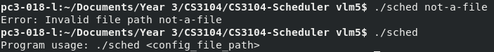
Figure 2: FIFO scheduler implementation
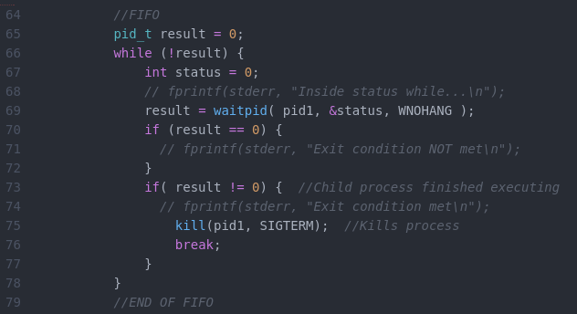

Conclusion

References
[1] Tutorialspoint File I/O: https://www.tutorialspoint.com/cprogramming/c_file_io.htm
[2] Going through a text file line by line in C: https://stackoverflow.com/questions/9206091/going-through-a-text-file-line-by-line-in-c
[3] Linked list implementation loosely based on my solution to CS2002 Practical 4 from last year

